1)

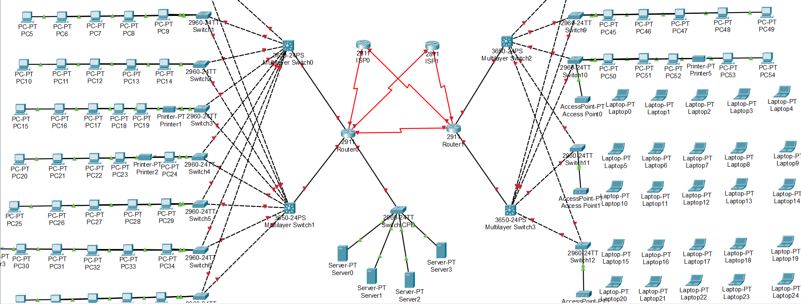

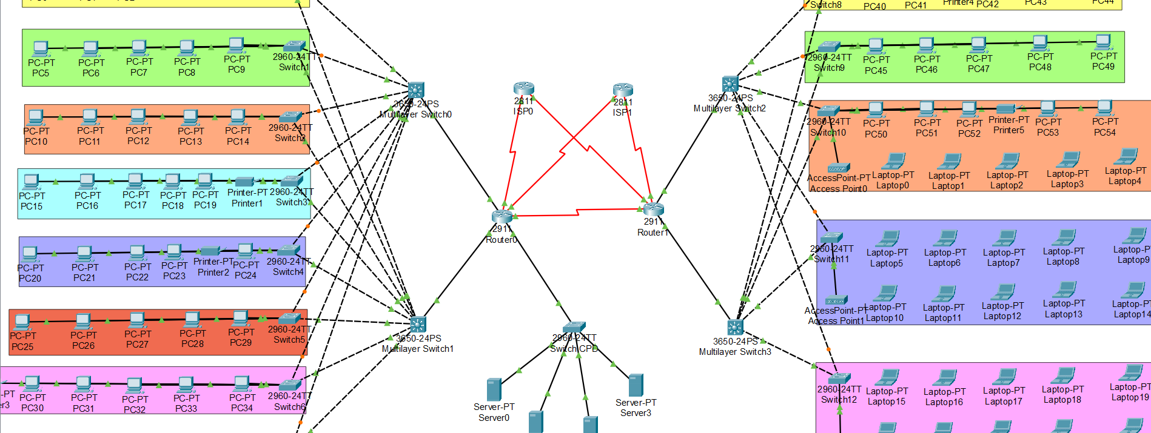

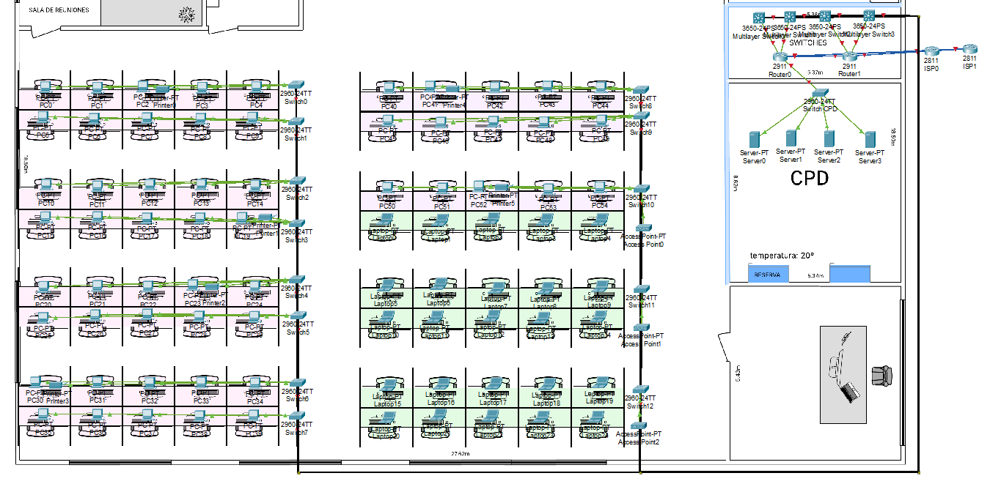

2)

encender aparatos

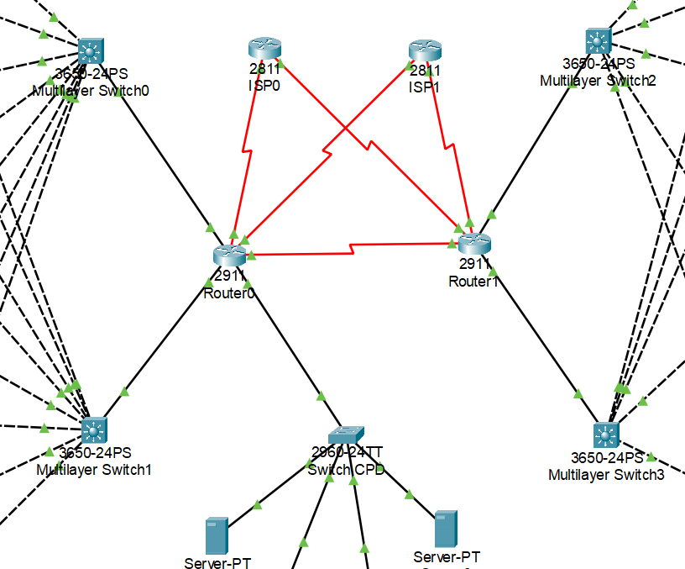

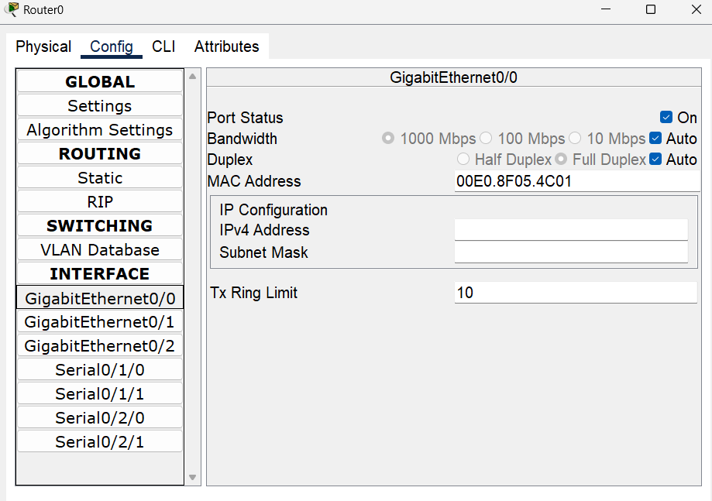

3)

configurar los switches

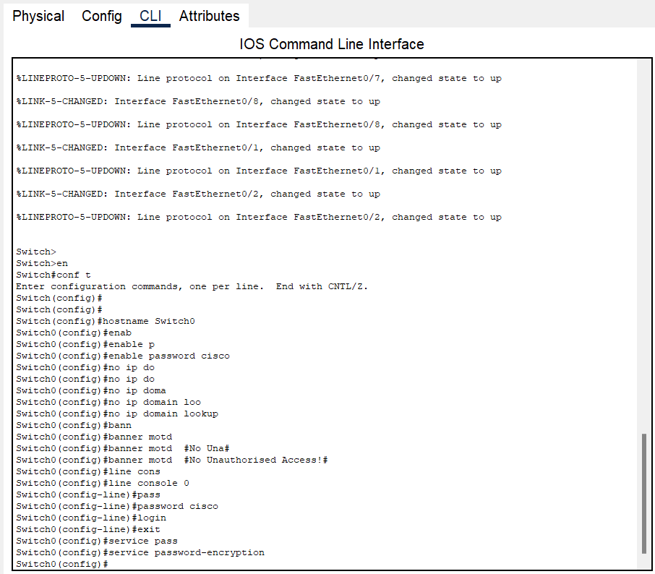

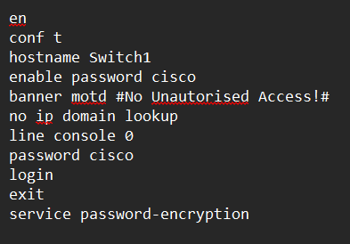

4)

configurar los switcher multicapa y routers

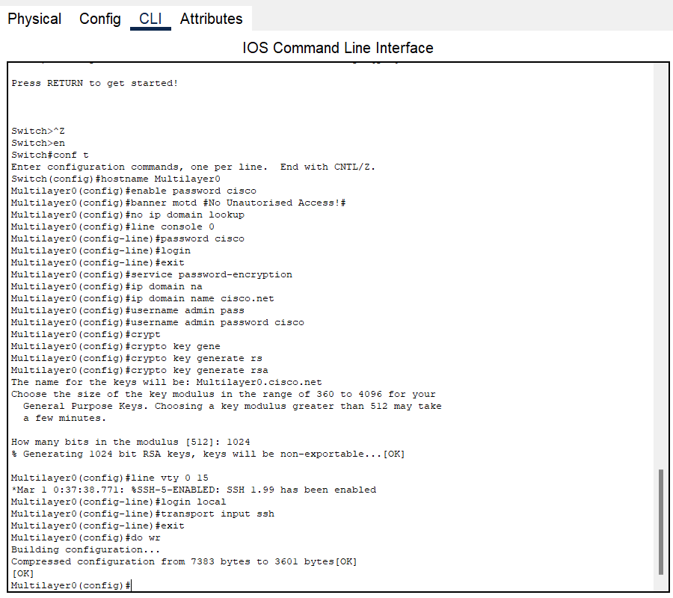

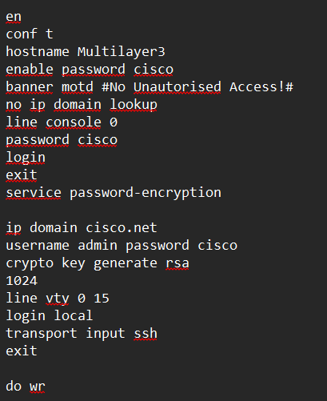

5) configurar vlans en CLI de switches y switches multicapas

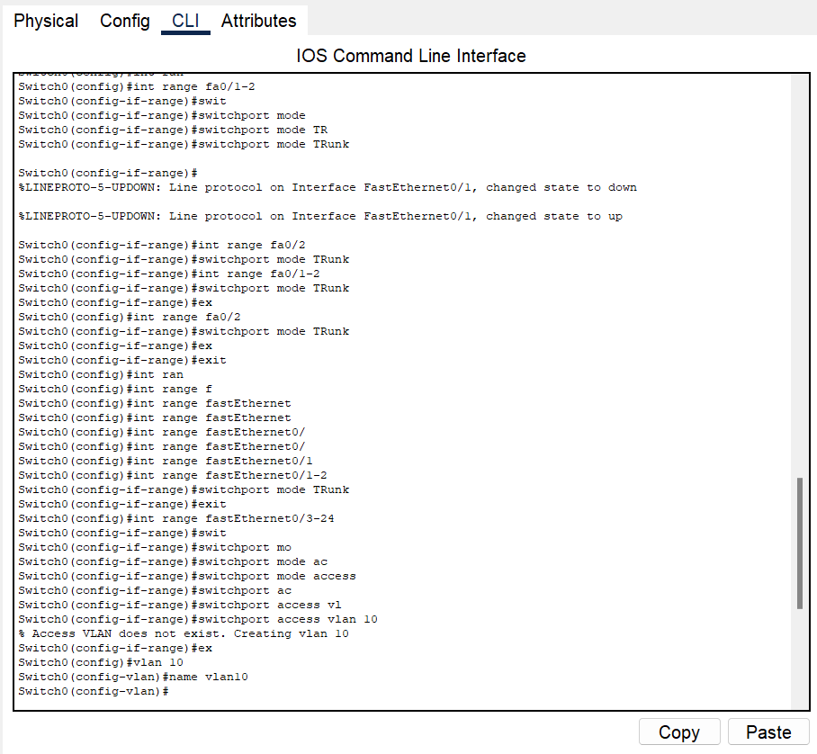

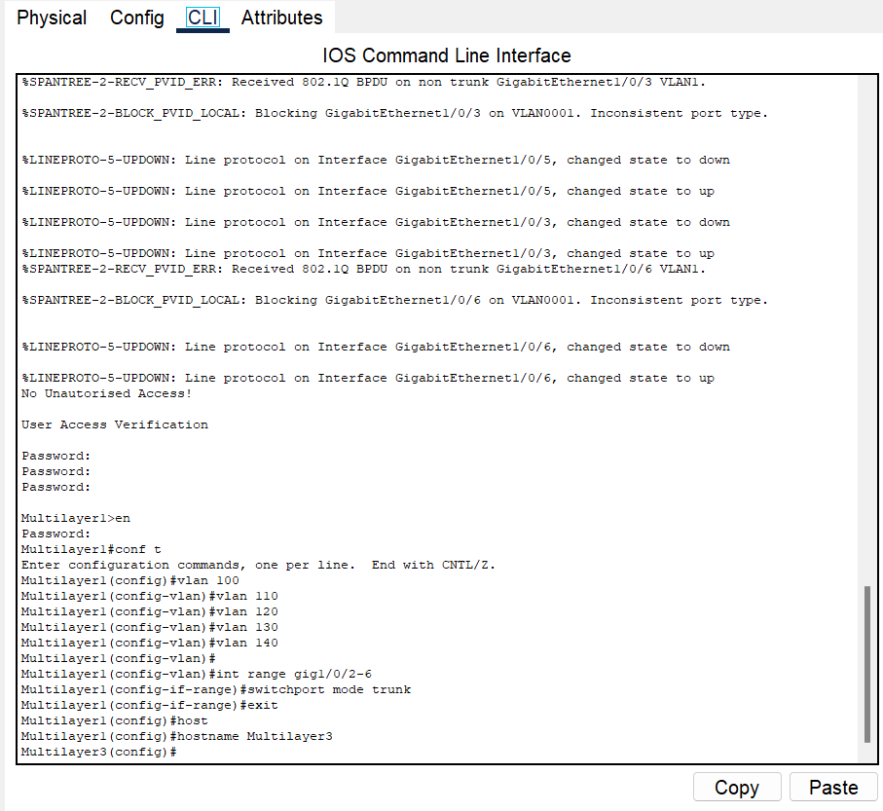

6)subredes

Tabla de subredes:

| **Subred #** | **Dirección de Subred** | **Rango Útil** | **Dirección de Broadcast** | **Asignado a** |
| --- | --- | --- | --- | --- |
| 1 | 192.168.100.0/27 | .1 – .30 | 192.168.100.31 | VLAN 10 |
| 2 | 192.168.100.32/27 | .33 – .62 | 192.168.100.63 | VLAN 20 |
| 3 | 192.168.100.64/27 | .65 – .94 | 192.168.100.95 | VLAN 30 |
| 4 | 192.168.100.96/27 | .97 – .126 | 192.168.100.127 | VLAN 40 |
| 5 | 192.168.100.128/27 | .129 – .158 | 192.168.100.159 | VLAN 50 |
| 6 | 192.168.100.160/27 | .161 – .190 | 192.168.100.191 | VLAN 60 |
| 7 | 192.168.100.192/27 | .193 – .222 | 192.168.100.223 | VLAN 70 |
| 8 | 192.168.100.224/27 | .225 – .254 | 192.168.100.255 | VLAN 80 |
| 9 | 192.168.101.0/27 | .1 – .30 | 192.168.101.31 | VLAN 90 (CPD) |
| 10 | 192.168.101.32/27 | .33 – .62 | 192.168.101.63 | VLAN 100 |
| 11 | 192.168.101.64/27 | .65 – .94 | 192.168.101.95 | VLAN 110 |
| 12 | 192.168.101.96/27 | .97 – .126 | 192.168.101.127 | VLAN 120 |
| 13 | 192.168.101.128/27 | .129 – .158 | 192.168.101.159 | VLAN 130 |
| 14 | 192.168.101.160/27 | .161 – .190 | 192.168.101.191 | VLAN 140 |
| 15 | 192.168.101.192/27 | .193 – .222 | 192.168.101.223 | ISP0 ↔ Router0 |
| 16 | 192.168.101.224/27 | .225 – .254 | 192.168.101.255 | ISP0 ↔ Router1 |
| 17 | 192.168.102.0/27 | .1 – .30 | 192.168.102.31 | ISP1 ↔ Router0 |
| 18 | 192.168.102.32/27 | .33 – .62 | 192.168.102.63 | ISP1 ↔ Router1 |
| 19 | 192.168.102.64/27 | .65 – .94 | 192.168.102.95 | Router0 ↔ Router1 |
| 20 | 192.168.102.96/27 | .97 – .126 | 192.168.102.127 | Router0 ↔ MLS0 |
| 21 | 192.168.102.128/27 | .129 – .158 | 192.168.102.159 | Router0 ↔ MLS1 |
| 22 | 192.168.102.160/27 | .161 – .190 | 192.168.102.191 | Router1 ↔ MLS2 |
| 23 | 192.168.102.192/27 | .193 – .222 | 192.168.102.223 | Router1 ↔ MLS3 |

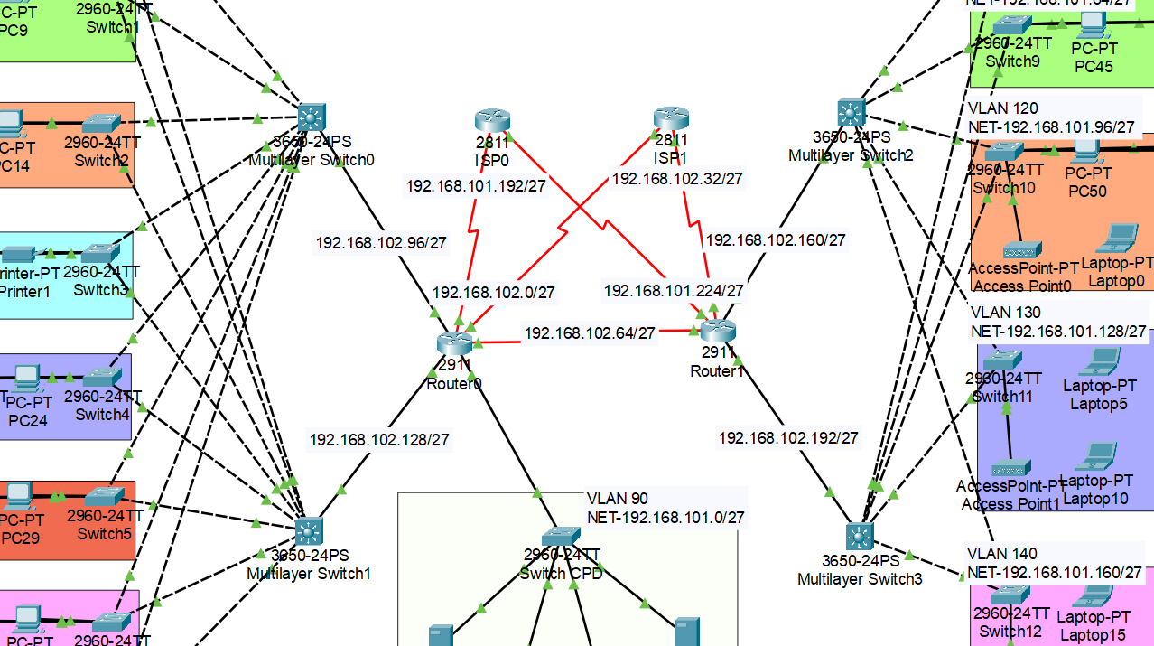

7) direccionamiento IP

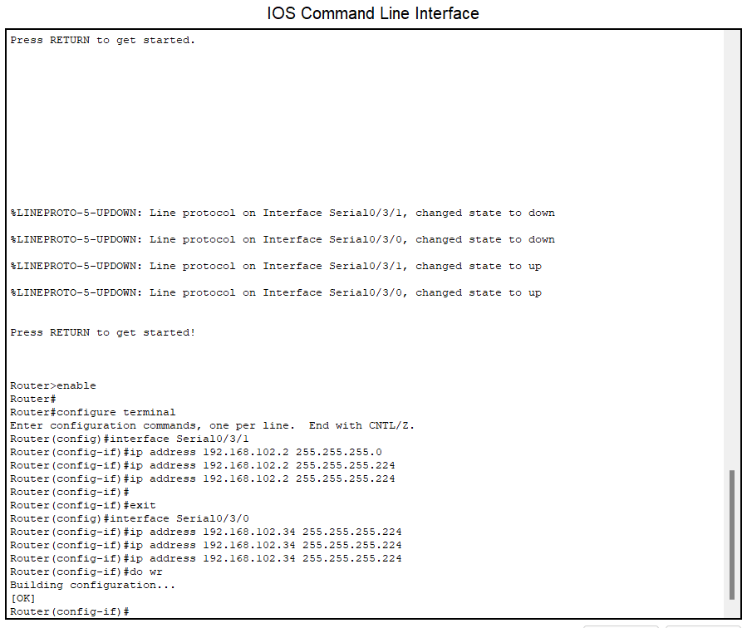

8)

configuración de OSPF

MLS:

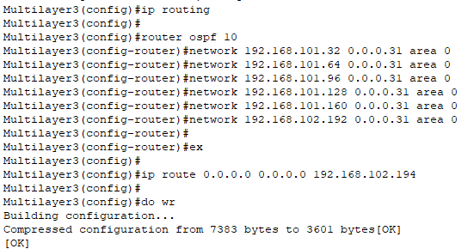

ROUTERS:

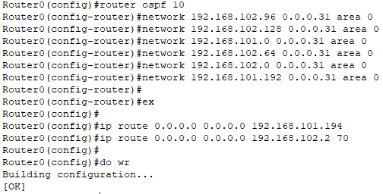

9) IP estáticos para servidores

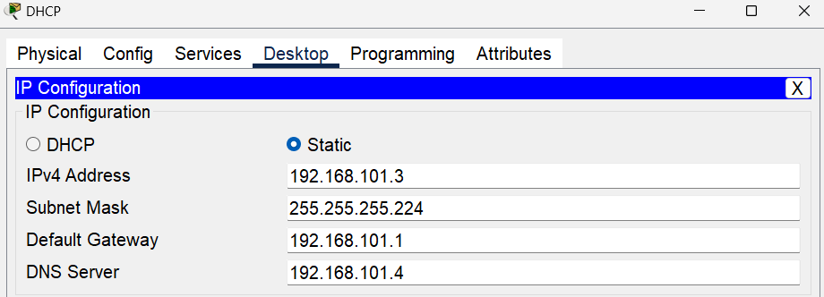

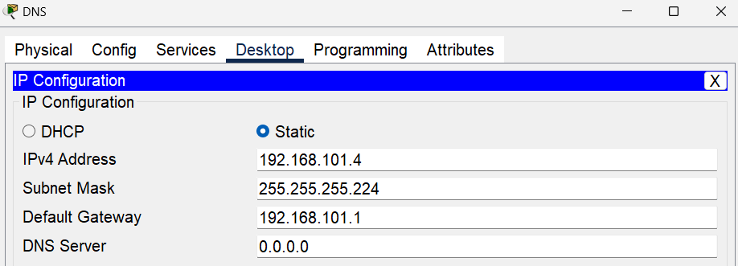

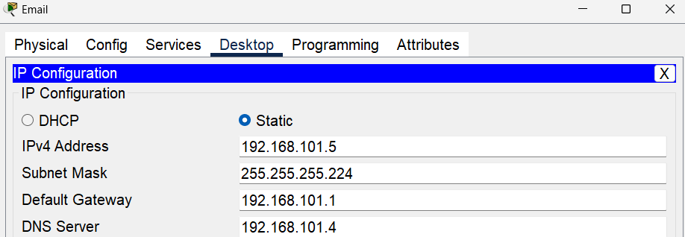

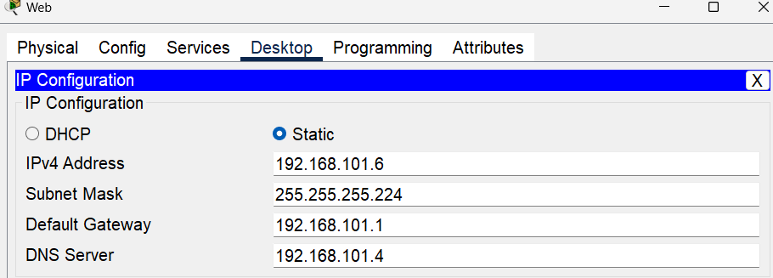

10) configuración del servidor DHCP

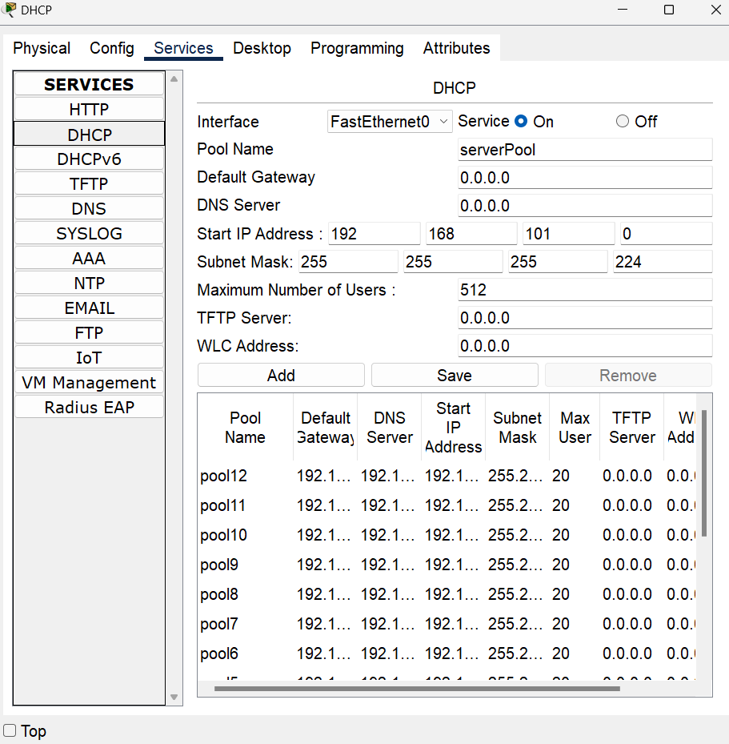

11)

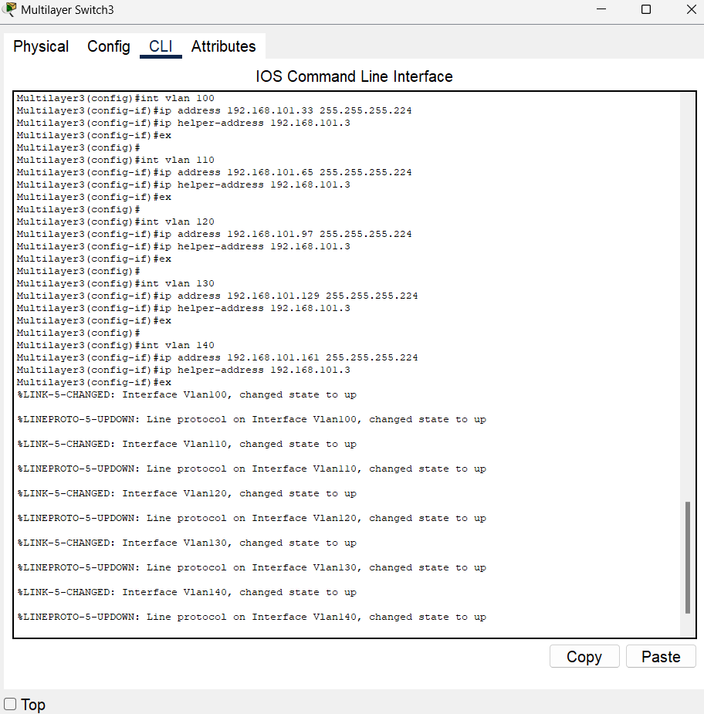

12) asignación de ips con DHCP para cada ordenador/impresora/

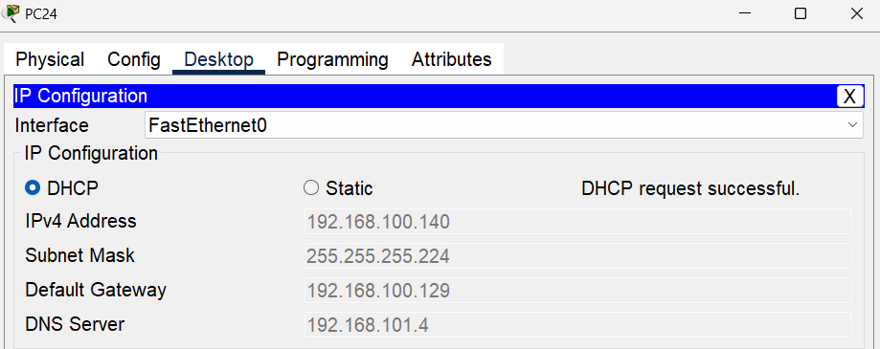

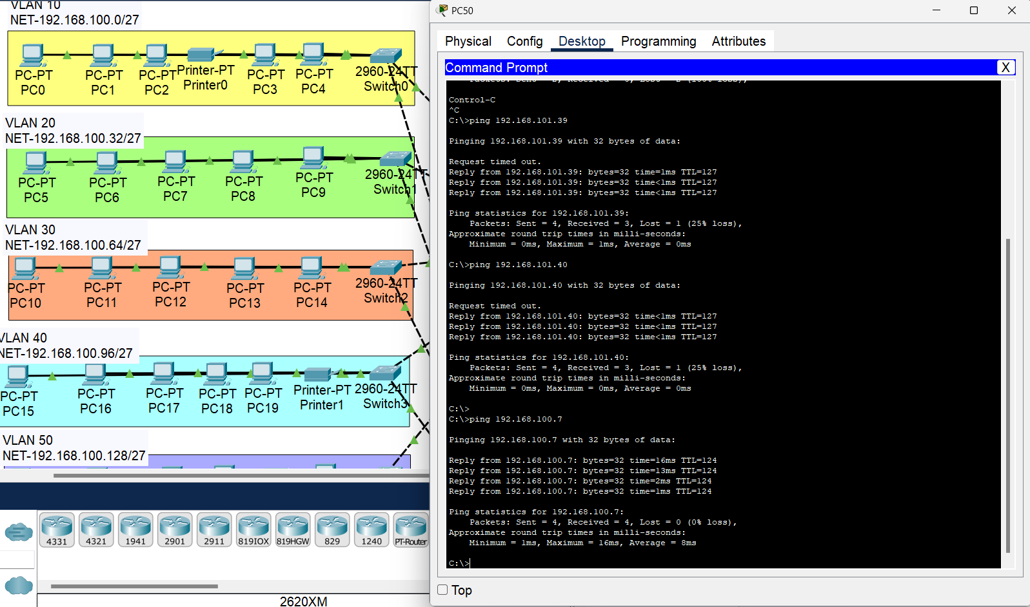

funciona toda correctamente

13)

configurar Wi-Fi

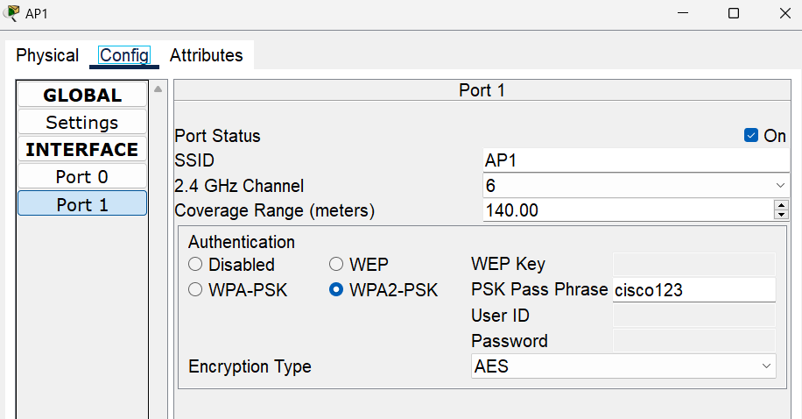

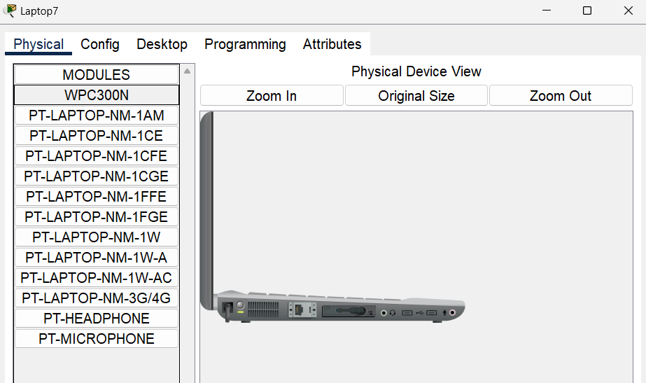

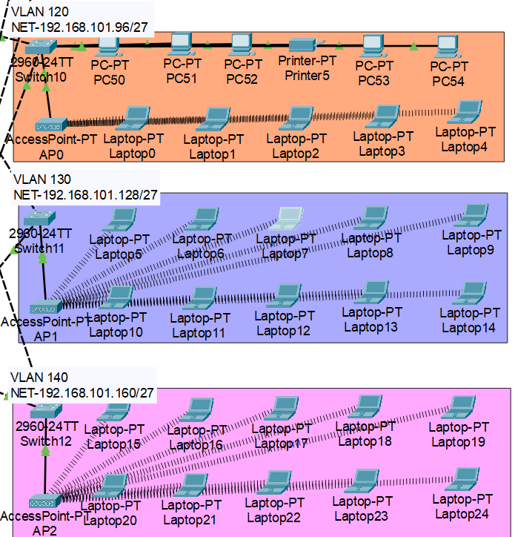

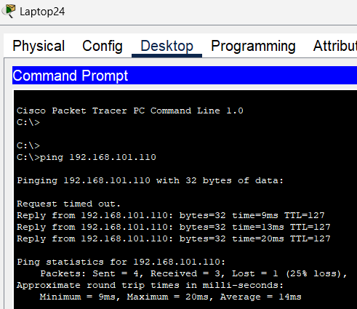

14)

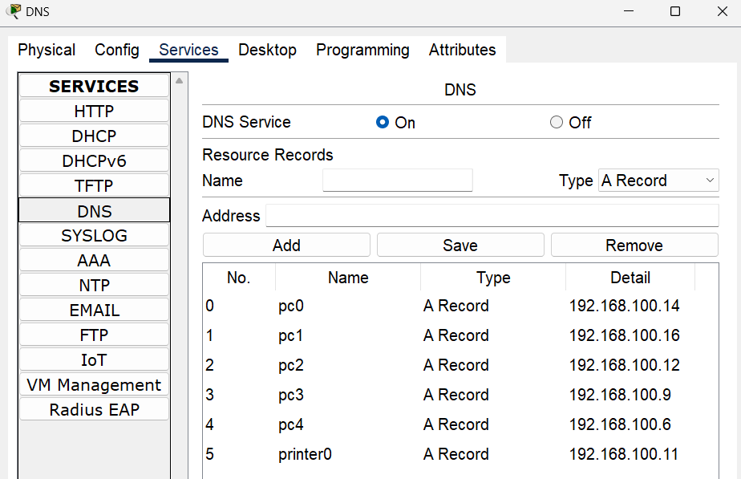

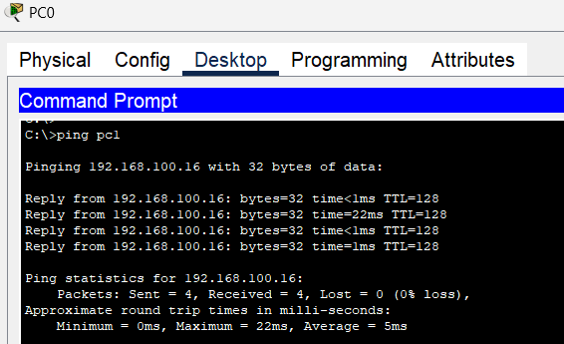

15)

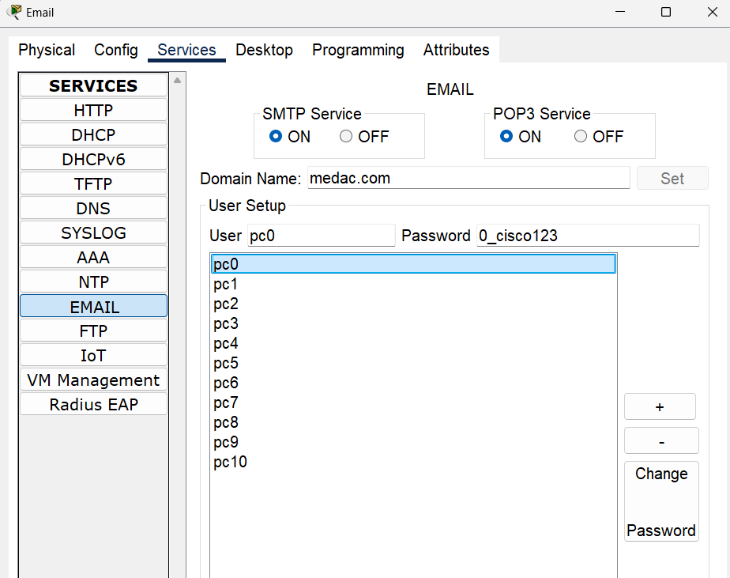

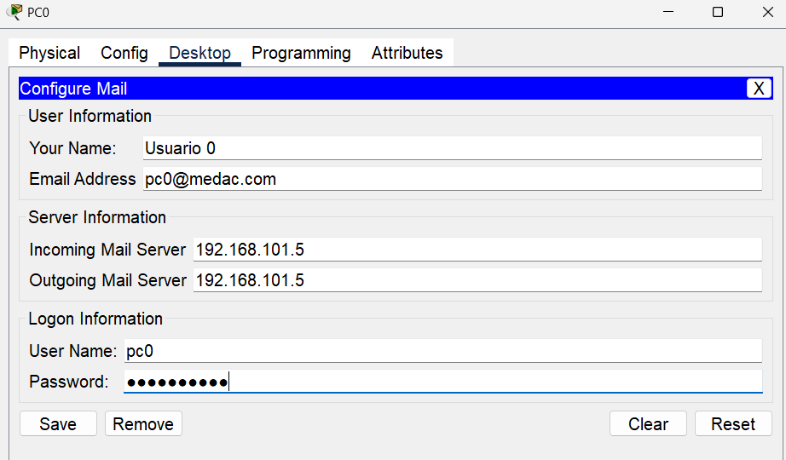

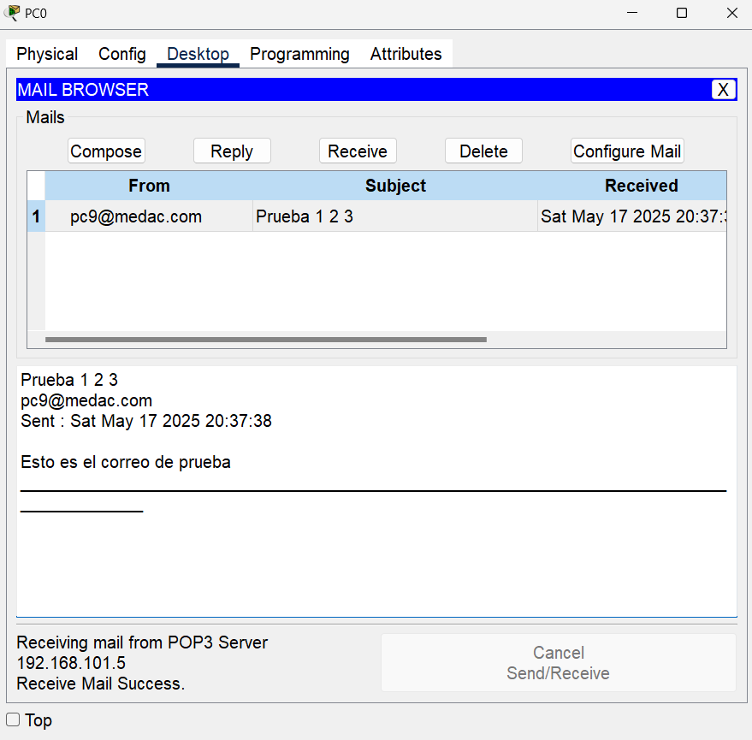

16)

